Box Canyon Creek: A comparison of habitat and fish above and below Peekaboo Falls to inform bull trout reintroduction
Scott Kline
Washington Department of Fish and Wildlife
Yakima, WA

SUMMARY
Box Canyon Creek has a bull trout population with low and variable number of redds each year, and because of this it has been identified as one of the 5 “Action Populations” in the Bull Trout Action Plan (2012). These “Action Populations” have been prioritized because they could become extinct with just a few years of poor spawning success. The Box Canyon Creek population lost a significant portion of its habitat with the creation of Kachess Dam, reducing the amount of habitat available for spawning and rearing fish, especially young-of-year. Peekaboo Falls is generally accepted as the current upstream extent of the available habitat for this population. The idea of creating passage at Peekaboo Falls to add 2.5 miles of fish bearing habitat to the 1.6 that is currently available has been considered as a recovery action. An analysis of habitat above and below Peekaboo Falls suggests that the larger number of pools and gravel substrate above Peekaboo Falls is more favorable for bull trout rearing and spawning, and that the amount of wood can provide similar quality habitat to what exists below Peekaboo Falls. The fish species composition above Peekaboo Falls includes a large number of westslope cutthroat and sculpin, suggesting that there is plenty of food for reintroduced bull trout. A bull trout reintroduction feasibility assessment and separate assessment of impacts to non-target species, both using published methods, suggest that feasibility of reintroduction is possible with little risk to the other species present. Reintroduction could be accomplished in many different ways with varying costs and pros and cons. Modifications to the recreational status quo above Peekaboo Falls must be considered if bull trout were reintroduced there, such as fishing regulations, recreational access and impacts to habitat.

INTRODUCTION
The purpose of this document is to assemble the information we have about the habitat above Peekaboo Falls to help inform efforts considering a bull trout reintroduction there. Background information is provided to understand why one would consider a reintroduction above Peekaboo Falls. A summary of habitat parameters and fish distribution observed both above and below Peekaboo Falls is presented to identify what we know about the habitat and fish assemblage. The intent is to spark discussion about the value of a bull trout reintroduction above Peekaboo Falls. Future discussion at multiple venues including the Bull Trout Working Group is expected to further discuss the feasibility and value of reintroducing bull trout above Peekaboo Falls. Primary information sources are the habitat surveys completed by the United States Forest Service (USFS) in 1989, 1995, and 2002, USFS’s watershed assessment in Box Canyon Creek in 1995, fish surveys by Plum Creek and the USFS in 1994 and 2000, and Washington Department of Fish and Wildlife’s (WDFW) habitat and demographic data collected between 2016 and 2024. An assessment of the feasibility of reintroduction of bull trout to waters above Peekaboo Falls was completed using published methods. An assessment of impacts to non-target species in those waters, using published methods, was also completed.

BACKGROUND
Box Canyon Creek is shown in Figure 1 along with several waterfalls that influence fish distribution within it. Peekaboo Falls, with a near-vertical drop between 3 and 3.5 meters, is the current upstream
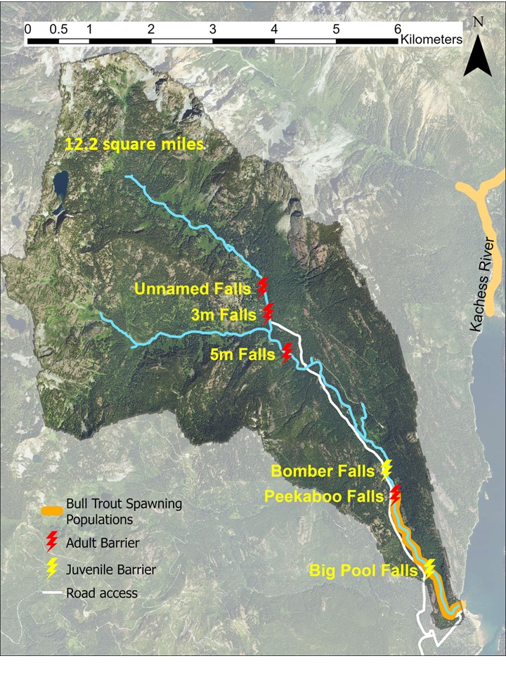
Figure 1. Box Canyon Creek including its waterfalls, road access, and current bull trout spawning distribution. Kachess River is shown for context.

extent of bull trout within Box Canyon Creek. The creek attracts visitors because of a popular, full-service USFS campground near the mouth of Box Canyon Creek, day use at the Peekaboo and Bomber falls, dispersed camping along the road and Box Canyon Creek, hiking and backpacking opportunities from Rachel Lake trailhead, snowmobile access in the winter, and other recreation. Poaching of bull trout at Peekaboo Falls has been documented since the 1980’s, but efforts to limit vehicle access and overnight camping at the site appears to have reduced, but not eliminated, this threat. All fishing is closed below Peekaboo Falls and fishing (primarily for resident cutthroat trout) is allowed above Peekaboo Falls.
The Washington Department of Fish and Wildlife, with assistance from other stakeholder agencies, have observed bull trout redds and bull trout adults and juveniles in Box Canyon Creek regularly since the 1980’s. WDFW staffers produced the earliest documented fish observations in Box Canyon Creek, which included exploration above Peekaboo Falls and the next major waterfall above that known locally as “Bomber Falls”. Reaches above Peekaboo Falls were checked for holding or spawning adult fish and redds in 1986, 1987, 1989, 1990, and 1993, (Brown L, personal files 1993) but none were found. Peekaboo Falls was noted as potentially passable in 1984, 1989 (Brown L, personal files 1993), and 2018 (Kline, personal communication) based on adult bull trout observed nearly jumping over the steepest portion of the falls. It has been hypothesized that historical passage at Peekaboo Falls may be dependent upon the woody debris configuration just below the falls, which can change the pool depth, thus effecting the jumping distance required to pass the falls (USFS 1995a, 2002).
The USFS reported Bull Trout use of Box Canyon Creek up to about Bomber Falls at RM 1.9 in their Box Canyon Watershed Analysis (1995a). In that same document, brook trout were documented up to the falls above the Rachel Lake Trailhead and were possibly planted in Box Canyon Creek in the 1920s and in 1953. Cutthroat and rainbow trout distributions were reported throughout Box Canyon Creek including the West Fork Box Canyon Creek, and both of those species had several stocking dates, the earliest of which was 1955 (cutthroat) and 1981 (rainbow), and the latest of which was 1994 (cutthroat) and 1993 (rainbow). No Bull Trout, brook trout or rainbow trout were observed above Peekaboo Falls in extensive surveys in 2017, and only occasional brook trout and rainbow trout juveniles have been observed below Peekaboo Falls in extensive surveys between 2016 and 2023. One anecdotal observation by a reputable volunteer fly-fisherperson was made of a 16- or 18-inch fish just upstream of Forest Road 4930 between 2010 and 2015. Though the person did not get it in hand, as the fish attempted to eat the cutthroat on their line the fish appeared to dark and too big to be a cutthroat.
On August 8, 1994, surveyors directed by Plum Creek Timber Company surveyed twelve 100-meter-long sites in Box Canyon Creek and documented bull trout and cutthroat in 5 size categories (Plum Creek 1995, Figure 2). The categories were separated into 3-inch intervals up to 12 inches in length and then one category for >12 inches They collected fish quantities in categories of sparse (1-10 fish), many (10-50), and numerous (50-100). They did not include bank observations as the WDFW surveys did, so their efficiency for observation of young-of-year fish is likely not as good as WDFW’s and their results are not directly comparable to WDFW’s. They started their first survey site 600 meters from the mouth. I used the pool elevation on that date (about 600 meters downstream of the campground and well into the inundation zone) to estimate where the mouth of the creek was and followed the thalweg stream distance of Box Canyon as observed in 2016 and 2017 habitat surveys to estimate the start location of each 100-m survey site. Estimated in this manner, the start of each site is at its most downstream possibility. If the start of each site was estimated by placing the zero point of the mouth of the creek at the high pool elevation near the campground, all sites would have been found about 600 meters further upstream. If the creek distance was estimated using a topographic map or modeled hydrology in GIS, all sites would have been further upstream by an undetermined amount because thalweg distance is longer than that shown on typical maps. Using this interpretation, the 1994 survey found bull trout above Peekaboo Falls and Bomber Falls, including fry that indicate that spawning occurred in 1993 assuming fry emerging from redds below Peekaboo Falls would be unable to ascend either falls. Larry Brown (personal files 1993) observed that debris jam below Peekaboo Falls was blown out in November 1989 and that the Peekaboo pool level was about one foot lower than normal in October 1990 (Brown personal files 1993). The USFS (1995a) stated that passage above Peekaboo Falls is dependent upon the woody debris configuration just below it, and that the large wood jam below Peekaboo Falls that blew out has not redeveloped since. Thus, any translocation of bull trout above Peekaboo Falls can be considered a reintroduction into previously occupied habitat.
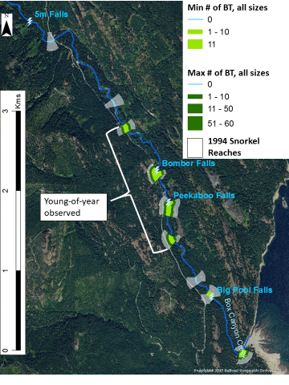
Figure 2. Location of night snorkel survey efforts in 1994 are shown along with the minimum and maximum amounts of bull trout found at 10 of the sites (2 adjacent to each other below Peekaboo Falls). The remaining 2 sites (not shown) were further upstream and no bull trout were found in them.

Figure 3 shows the 1901 extent of habitat in Box Canyon Creek prior to the creation of any dams on Lake Kachess, as seen in the United States Geological Survey Washington Snoqualmie Quadrangle printed in 1903. Once Lake Kachess was modified with a crib dam in 1904 and the full dam was complete by 1912, the lower 700-800 meters of Box Canyon Creek (red rectangle in Figure 3) was severely altered by timber extraction and annual inundation and dewatering cycles. This lost habitat is at least 27% of the total current available habitat (700m/2546m) up to Peekaboo Falls and at least 72% of the total current
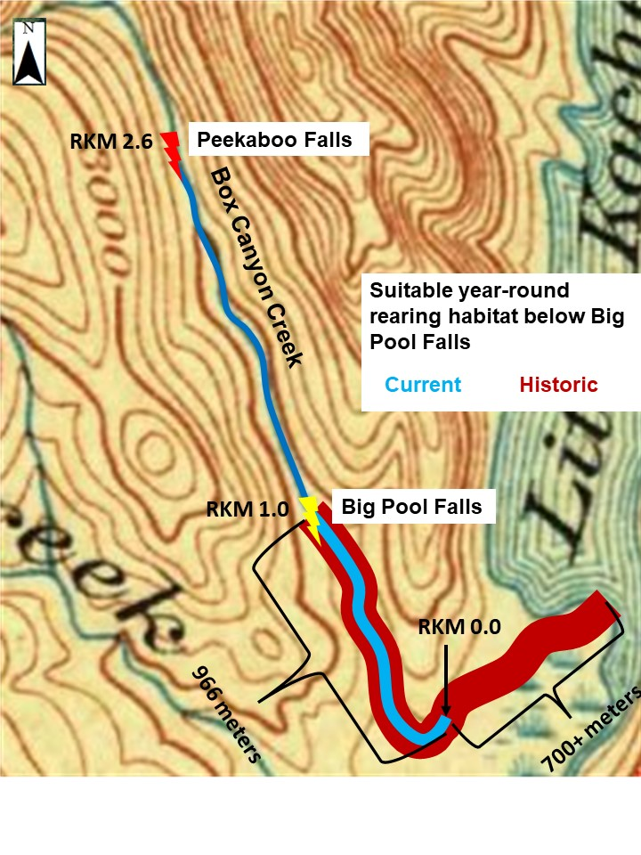
Figure 3. Habitat contraction due to reservoir expansion. This portion of a 1903 survey map shows the extent of Lake Kachess and its upper lobe, Little Kachess, before the creation of any dams on Lake Kachess. Under current operations the high pool elevation is at the downstream end of the wide blue line.

available habitat up to Big Pool Falls (700m/966m), a 2-meter falls at RM 0.6. This loss of habitat below Big Pool Falls is significant in light of observations during snorkel and bank observation surveys that suggest the lower portion of Box Canyon Creek just above the inundation zone is the primary rearing area of young-of-year bull trout. In 2016, WDFW observed that 100% of the young-of-year bull trout were below Big Pool Falls while older age classes were found above and below Big Pool Falls (Kline and Meyer, 2017a). The YOY observed in 2016 were produced from the 2015 spawning brood. No YOY were observed above Big Pool Falls in 2016, so all of the YOY from the three redds observed in 2015 above Big Pool Falls either migrated downstream of the waterfall or were transported there by high flows and contributed to the YOY observations in 2016 or perished before then. In 2017, 63% of the YOY observed were above Big Pools Falls while 37% were observed below Big Pool Falls (Kline, 2018). In 2016, the year in which the redds that produced the YOY observed in 2017 were created, all 7 of the redds observed in the entire index reach were found above Big Pool Falls. In 2018, 16% of the YOY observed were above Big Pool Falls, and 84% were below Big Pool Falls (Kline and Meyer, 2019). 33% (1) of the redds that produced the YOY observed were above Big Pool Falls while 66% (2) of the redds were below the falls. In 2019, 34% of the YOY observed were above Big Pool Falls, and 67% were below Big Pool Falls (Kline, unpublished data). 57% (8) of the redds that produced the YOY observed were above Big Pool Falls while 43% (6) of the redds were below the falls. Assuming an even distribution of YOY bull trout relative to redd locations, we would have expected to see a larger percentage of YOY above Big Pool Falls in all four years. These observations suggest that no matter the redd distribution, YOY end up downstream of Big Pool Falls. Since Big Pool Falls is an upstream passage barrier to YOY and the impoundment of Lake Kachess by the dam in 1912 eliminated instream habitat near the reservoir, these bull trout YOY are squeezed in just 57% of the rearing habitat (966m/1666m) they had prior to Kachess Dam.
Figure 4 shows the number of redds observed annually in Box Canyon Creek. The very low redd counts in many years indicate that this population is at risk of extirpation (Reiss et al 2012). In addition, habitat surveys by WDFW in 2016 below Peekaboo Falls (Kline and Meyer, 2017) showed that the wood load with respect to number of pieces met the USFS standard, but not standards of more modern guidelines (Watershed Professionals Network (WPN) 1999, Fox and Bolton 2007, and FPB 2011). The recommended number of key pieces was also not met (WPN 1999, Fox and Bolton 2007). While some logging in the Box Canyon Creek watershed has been noted (USFSa, 1995), observations of large tree trunks sawn off with root wads still attached to the stream banks in many places suggests those trees were removed and now unable to contribute ecologically to the stream and the resources they would have supported.
Thus, the loss of habitat due to the construction of the dam, the limited rearing opportunity for early age classes of bull trout inherent to Box Canyon Creek hypothesized due to Big Pool Falls, the low and variable numbers of redds found each year, and the lack of instream wood below Peekaboo Falls (up until 2019) has necessitated a look at the potential for providing fish passage over Peekaboo Falls and Bomber Falls. Passage could take the form of adult passage to access spawning habitat or translocation of younger age classes to access the currently unoccupied rearing habitat.

Figure 4. Number of bull trout redds in Box Canyon Creek. 2007 and 2016 were incomplete surveys (red dots) due to high flows and likely underestimated the number of redds.

COMPARISONS Above and Below Peekaboo Falls
Surveys by the USFS and WDFW are available to determine how habitat and fish assemblage compares above and below Peekaboo Falls. Those comparisons of specific parameters are summarized in this section. Figure 5 shows the survey reaches for WDFW’s 2016 and 2017 habitat surveys, and the USFS habitat surveys from 1989, 1995, and 2002 (USFS 1989, USFS 1995, USFS 2002). While the above/below Peekaboo Falls comparison can be made within each year, the same areas above and below are not
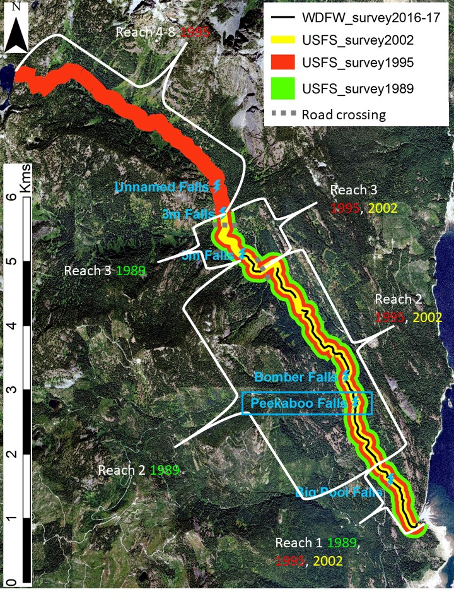
Figure 5. Habitat surveys in Box Canyon Creek by USFS and WDFW. Data is available both below and above Peekaboo Falls to evaluate differences in habitat in multiple years.
always consistent between years. The USFS 1989 report surveyed three separate reaches of Box Canyon Creek. Reach 1 was from the creek mouth up to the transition to a lower gradient, wider stream with more gravel and cobble substrate (RM 0.8) and for the purposes of this analysis represent the habitat below Peekaboo Falls. Reach 2, in 1989, was from that transition to the confluence with the West Fork (3.2 miles). Since reach 2 includes area above and below Peekaboo Falls, and data is available only for reach totals in 1989 and 1995, it is ignored in this comparative analysis for those years. Reach 3 is from the confluence with the West Fork to the downstream end of the cascades near Rachel Lake trailhead and for the purpose of this analysis represents the habitat above Peekaboo Falls (Figure 5). Note that the WDFW survey did not include observations of pools, wood, or wetted and bankfull widths in Reach 3 overlapping the 1989 survey so that year’s data sets may not be directly comparable when evaluating habitat above Peekaboo Falls. Observations of gradient, length, and waterfalls were taken in that 1989 reach by USFS. The USFS 1995 report adjusted the reaches described above so that the break between reaches 2 and 3 became the first road crossing of Forest Road 4930 as one goes upstream, 0.5 miles downstream of the 1989 Reach 2 end. The USFS 2002 survey split Box Canyon Creek into the same reaches as the 1995 survey but also subdivided reach 2 and reach 3 into several sub-reaches, which allows a closer comparison to WDFW surveys. The WDFW surveys above and below Peekaboo falls were in two adjacent field seasons and the WDFW survey above Peekaboo Falls includes 2.2 miles of stream length versus 0.4 miles in the USFS 1989 survey, 0.8 miles in the USFS 1995 survey, and 0.9 miles in the USFS 2002 surveys. For clarification, the WDFW habitat surveys encompassed the entire length of stream from the high pool Kachess reservoir elevation (RM 0) to Peekaboo Falls (RM 1.6), Peekaboo Falls up to RM 3 (1.4 miles), RM 3.1 to RM 3.5 (0.4 miles), and RM 3.7 (a.k.a FR 4309 culvert) to RM 4.1 (a.k.a. 5M Falls, 0.4 miles). Regardless of what was surveyed, note that the amount of annual habitat available below Peekaboo Falls is 1.6 miles (2.5 km) and above Peekaboo Falls is 2.5 miles (4 km). Above Peekaboo Falls is the distance from Peekaboo Falls at RM 1.6 to the 5-meter vertical water fall at RM 4.1.

Large Wood Habitat
The 1989 Box Canyon Creek survey found that in-channel large wood did not meet Forest Standards both above and below Peekaboo Falls. Table 1 provides a summary of the amount of wood in each major reach during surveys in 1989, 1995, 2002, and 2016/17. More wood was found below Peekaboo Falls than above in all years when considering USFS criteria, so fish habitat above Peekaboo Falls appeared less-favorable to below Peekaboo Falls when looking at the reaches in general. The 1995 survey report also included a recommendation to “introduce woody debris and other habitat structures to channel”. Table 2 provides a summary of the amount of wood in each relevant sub-reach during surveys in 2002 and 2016/17. The 2016 and 2017 WDFW surveys found more wood than the 1989 survey, more wood than the 1995 survey, and more OR less wood than the 2002 survey (depending on which reach), when considering qualifying USFS wood. This suggests an increasing trend in the amount of wood through the Box Canyon system but all survey years suggest that wood load below Peekaboo Falls may be providing better habitat than above Peekaboo Falls. However, the wood load recommended by the finer-scale, more spatially appropriate measures of the Fox and Bolton 2007 protocol suggest that habitat above Peekaboo Falls is similar, if not better than, below Peekaboo Falls. In 2019, the Kittitas Conservation Trust implemented a large woody habitat project below Peekaboo Falls that greatly increased the quantity large woody habitat in Box Canyon Creek below Peekaboo Falls. While this wood is expected to increase velocity refuge for the young-of-year and juvenile fish below Peekaboo Falls, this population is at such low levels that wood alone is not expected to alleviate the limiting factors in Box Canyon Creek, which includes contracted habitat caused by loss of the lower 700 meters of Box Canyon Creek since the creation of Kachess reservoir, and rising water temperatures.

Table 1. Box Canyon Creek habitat survey results from four different surveys between 1989 and 2017, both below and above Peekaboo Falls.
Surveyor | Year | Parameter | Above Peekaboo | Below Peekaboo
USFS | 1989 | USFS wood/mi | 8 | 31
USFS | 1995 | USFS wood/mi | 25 | 29
USFS | 2002 | USFS wood/mi | 34.6 | 69
WDFW | 2016/17 | USFS wood/mi | 40 | 47
WDFW | 2016/17 | Fox-Bolton wood/100m | 16 | 15.5
USFS | 1989 | USFS all pools/mi | 36.1 | 33.3
USFS | 1995 | USFS all pools/mi | 34.6 | 27.3
USFS | 2002 | USFS all pools/mi | 23.8 | 23
WDFW | 2017 | USFS all pools/mi | 31.7 | 37.0
USFS | 1995 | USFS pools >3’/mi | 9 | 6.5
WDFW | 2017 | USFS pools >3’/mi | 9.5 | 8.2
Watson | 1990 | Fine sediment <1mm | <10% 5 of 6 sites, 1 of 6 = 16.8% | <10% 3 of 3 sites
WDFW | 2016/17 | % fines at surface | <5% | <5%
WDFW | 2016/17 | Dominant substrate gravel or cobble | 85.2% | 61.3%
WDFW | 2017 | Gradient | 1.7%* | 2.8%
* = between Peekaboo Falls at RM 1.6 to 5-meter falls at RM 4.1.

Table 2. Box Canyon Creek habitat survey results from the recent WDFW survey in comparison to the 2002 survey where USFS reaches were more comparable to WDFW reaches.
Surveyor | Year | Parameter | Above Peekaboo  Reach 2.2 | Above Peekaboo Reach 2.3 | Above Peekaboo Reach 3.1 | Below Peekaboo Reach 1
USFS | 2002 | USFS wood/mi | 48 | 15 | 28 | 69
WDFW | 2016/17 | USFS wood/mi | 52.5 | 15.3 | 15.5 | 59
WDFW | 2016/17 | Fox-Bolton wood/100m | 18.4 | 5.5 | 7.9 | 16.5
USFS | 2002 | USFS all pools/mi | 29 | 23.1 | 41 | 23.1
WDFW | 2017 | USFS all pools/mi | 28.9 | 12.3 | 46.6 | 46.7
WDFW | 2017 | USFS pools >3’/mi | 7.0 | 9.2 | 15.5 | 11.4
Watson | 1990 | Fine sediment <1mm | 3 of 3 sites <= 10% | 3 of 3 sites <= 10% | 3 of 3 sites <= 10% | 3 of 3 sites <10%
WDFW | 2016/17 | % fines at surface | 1.1% | 0.6% | 0.0% | <5%
WDFW | 2016/17 | Dominant substrate gravel or cobble | 94% | 83% | 44% | 49%
WDFW | 2017 | Gradient

Pools
The area surveyed for pools was the same as that for wood. The 1989 Box Canyon Creek survey found that reach 1 (fully below peekaboo falls) and reach 3 (fully above peekaboo falls) did not meet forest standards for pools. Reach 2 (in areas below and above peekaboo falls) did meet forest standards, just barely, with 94 pools. On average more pools have been found above Peekaboo Falls than below when considering the survey results as a whole. In the recent WDFW surveys compared to the 2002 USFS survey (when reaches could be more closely associated with the WDFW surveys), fewer big pools (>3’ residual depth) were found in most of the surveyed habitat above Peekaboo falls than below, and more big pools were found high up in the system (between the first road crossing and the 5-meter falls). With respect to pools, the habitat above Peekaboo Falls appears similar overall to below Peekaboo Falls.

Substrate
The area surveyed for substrate was the same as that for wood. By three different measures of substrate (fine sediment <1mm, % fines, and % of habitat that is gravel/cobble dominant), the habitat above Peekaboo Falls appears as suitable for spawning and rearing of bull trout, if not better than below Peekaboo Falls. The one high fine sediment reading above Peekaboo Falls in 1990 may have been influenced by local logging activity in that period. The Watson 1991 report does not show the sample sites in detail so this can not be evaluated against current conditions.

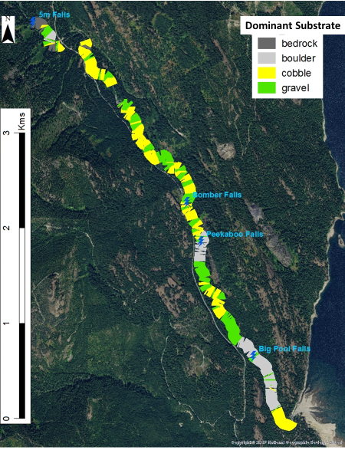
Figure 6. Dominant substrate type throughout the surveyed area of Box Canyon Creek.

Gradient
The area surveyed for gradient by the WDFW was from the mouth of Box Canyon Creek at the high pool reservoir level to the unnamed 3-meter falls at RM 4.6. The gradient above Peekaboo Falls appears more suitable for spawning and rearing bull trout than below Peekaboo Falls. Of note is the much larger proportion of pool habitat (as noted by the length of habitat with zero-gradient) and >0-1% gradient habitat above Peekaboo Falls than below Peekaboo Falls (Figure 7). The habitat above the unnamed 5-meter falls (RM 4.1) is not likely worth reintroducing bull trout to because of the high gradient environment there, especially 0.4 miles upstream of the falls (Table 3, Figure 8). Also of note is the large amount of high gradient habitat in the lower third of the habitat below Peekaboo Falls. This habitat is not conducive to young-of-year occupancy given the high velocities that are likely to occur here and the proclivity for young-of-year to move downstream once emerged from their spawning area. Fish that end up in this high gradient reach are more likely to be forced downstream to the reservoir where they are not likely to contribute to the next age classes (Downs et al 2006). A more common geomorphic pattern in Yakima Basin bull trout streams is to have the higher gradient habitat in the upstream reaches of the population and the lower gradient habitat in the downstream reaches of the population. This pattern is likely more conducive to young-of-year survival. Further habitat evaluation could take the form of flow modeling comparisons between the reaches above and below Peekaboo Falls.

Figure 7. Amount of low (0-2), medium (>2-5), and high (>5) gradient habitat below Peekaboo Falls, between Peekaboo Falls and the 5-meter falls (5M), and above the 5-meter falls above Peekaboo.

Table 3. Waterfalls and cascades in Box Canyon Creek.
Reach | Feature | Gradient % | River Mile | Vertical Drop (m) | Passable by Adults (A), Juveniles (J), Fry (F)
Below Peekaboo Falls | Big Pool Falls | 11.5 | 0.6 | 2 | A, J?
Below Peekaboo Falls | unnamed cascades | 12 | 1.5 | na | A, J, F?
Below Peekaboo Falls | unnamed cascades | 9.8 | 1.58 | na | A, J, F?
Peekaboo to 5M falls | Peekaboo Falls | 41 | 1.6 | 3-3.5 | None currently
Peekaboo to 5M falls | Bomber Falls | 50 | 1.9 | 2.5 | A?
Peekaboo to 5M falls | unnamed falls | 70 | 3.9 | 1.3 | A, J
Peekaboo to 5M falls | cascades | 9.5 | 4 | na | A, J, F?
Peekaboo to 5M falls | 5m Falls | 500 | 4.1 | 5 | None
Above 5m Falls | cascade | 10 | 4.54 | na | A, J
Above 5m Falls | cascade | 13 | 4.57 | na | A, J
Above 5m Falls | cascade | 11.5 | 4.58 | na | A, J
Above 5m Falls | 3m Falls | 300 | 4.6 | 3 | None
? = unknown for that particular life stage
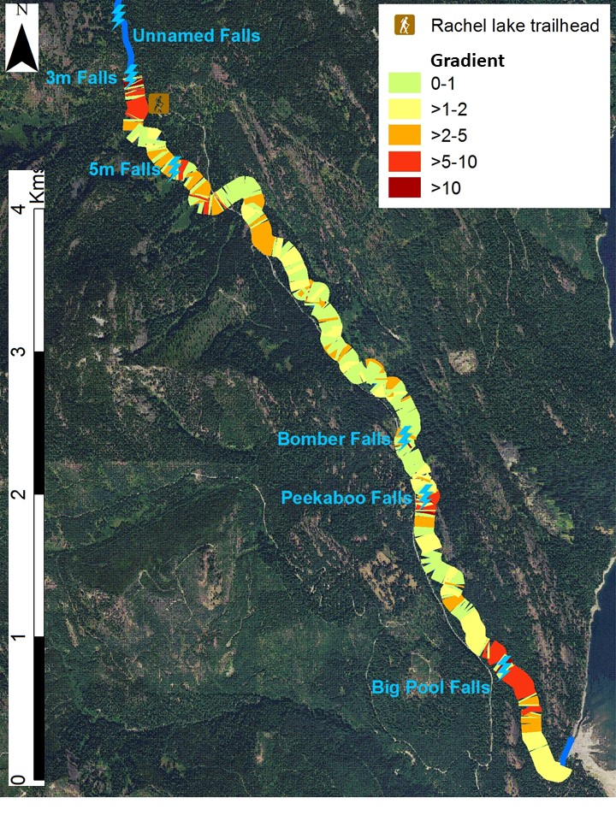
Figure 8. Percent gradient throughout the surveyed area of Box Canyon Creek.

Temperature
The temperature below Peekaboo has been monitored just upstream of the Kachess campground around RM 0.2 (RKM 0.3) as early as 1995 by the USFS and continues to current day by the WDFW (unpublished data), though not continuously. Temperature monitoring at a waterfall known as “5M Falls” at RM 4.1 (RKM 6.5), representing conditions above Peekaboo Falls and near the most upstream extent of the Bull Trout potential distribution, is available for 2020 through 2024, though not continuously. The August average mean water temperature is used by the NorWeST temperature model as the primary metric to compare water temperatures between different streams and years because “the summer is critical for growth and survival of many aquatic species in the western U.S. and this metric is strongly correlated with other commonly used summer temperature metrics” (Isaak et al 2017). In Box Canyon Creek August also is typically when the peak water temperatures occur, so the August mean represents the thermal maximum that cold water species like Bull Trout experience. In the three years where August means are available above and below Peekaboo Falls, above Peekaboo Falls was 2.6 to 2.7 degrees C cooler than below Peekaboo Falls (Figure 9).

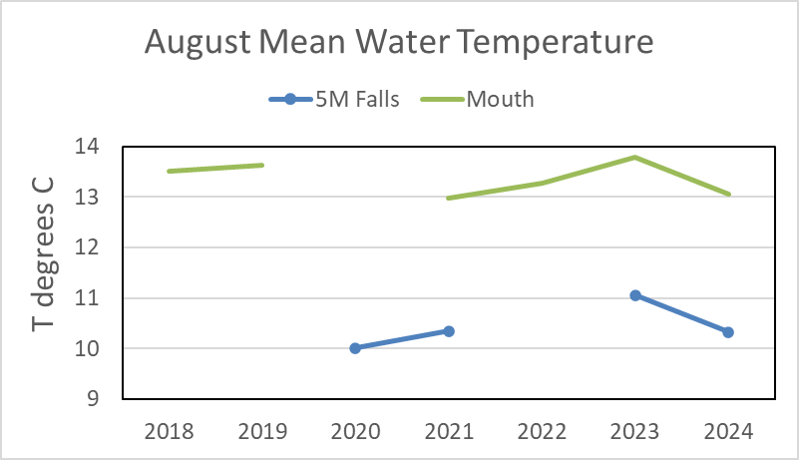
Figure 9. Temperature comparison above and below Peekaboo Falls in Box Canyon Creek.

Fish
Figure 10 shows fish densities in three different streams in the Yakima Basin where bull trout are found. Survey methods are described in summary reports by Kline and Meyer in 2017 and 2019 and Kline in 2018. Surveys were conducted both above and below Peekaboo Falls in one year: 2017 (Kline 2018). Other years below Peekaboo Falls are provided for comparison purposes to show variability of the fish assemblage below Peekaboo Falls. Results from surveys completed in the S.F. Tieton with the same methods in 2018 are presented as a comparison to a population that is generally accepted to be stable and of high abundance. Results from surveys completed in the Kachess River with the same methods in the same years as Box Canyon are presented as a comparison to a population in the same time period that is also considered low abundance. The densities of cutthroat trout above Peekaboo Falls were found to be nearly 3 times greater than any other location surveyed. The densities of sculpin species above Peekaboo Falls were found to be 2.5 times greater than any other location surveyed. Of the 1324 cutthroat observed above Peekaboo Falls, 237 were young-of-year (1”- 2”), 780 were between yoy and 100 mm (2” to just under 4”), 276 were between 100 mm and 200 mm (4” – just under 8”), and 31 were between 200 and 300 mm (8” - just under 12”). This observation suggests two important points regarding reintroducing bull trout above Peekaboo Falls: 1) there is a lot of food for larger bull trout and 2) efforts to reintroduce bull trout above Peekaboo Falls must consider the amount of predation on introduced bull trout by cutthroat and resource competition with cutthroat and sculpin. If young-of-year bull trout were the only age class available to reintroduce above Peekaboo Falls, the number of them that would have to be reintroduced to seed a viable population could be greater than what is currently expected to be readily available from fish rescue efforts in the basin. If a reintroduction program began above Peekaboo Falls (and Bomber Falls), careful consideration of the number of Bull Trout available and the size at which they are reintroduced (with the understanding that the larger the fish the more likely it will reach maturity) needs to be considered to optimize the adult returns expected from the reintroduction. Adults introduced above Peekaboo and Bomber Falls could escape predation by cutthroat but predation by humans would become a concern due to the large amount of recreational activity in that area.

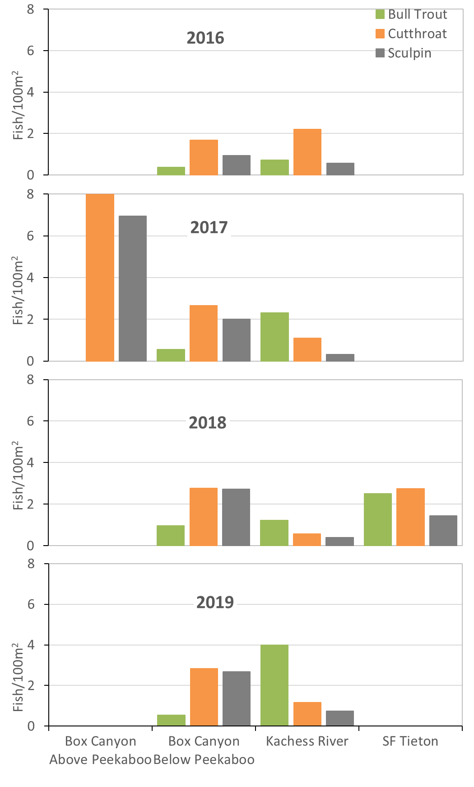
Figure 10. Bull trout, cutthroat trout, and sculpin species observed during demographic surveys in Box Canyon Creek above and below Peekaboo Falls, the Kachess River, and the S.F. Tieton.

A comparison of cutthroat densities in other streams with no or few competing salmonids can help us put the Box Canyon Creek cutthroat densities in context. A summary of fish survey data was provided in Idaho Fish and Game (2013). In seven creeks within the Priest River watershed, where neither bull trout nor brook trout were found, cutthroat densities averaged 7.2 fish/100m² using electrofishing (range 1.31 to 17.6 fish/100m², Dupont et al, 2008). In three creeks within the Pend-Oreille watershed, where neither bull trout nor brook trout were found or were found at densities of 0.1 fish/m² or less, cutthroat densities averaged 17.5 fish/100m² using electrofishing (range 1.7 to 43.7 fish/100m², Ryan and Jakubowski 2012). In two creeks within Pine Creek, a tributary to the South Fork Coeur d’Alene watershed, where neither bull trout nor brook trout were found, cutthroat densities averaged 8.1 fish/100m² using snorkeling (range 0.43 to 27.1 fish/100m², Idaho Fish and Game 2013). Finally, recent night time snorkel surveys in the upper reaches of the N.F. Little Naches River, where there are no Bull Trout, Brook Trout, or Rainbow Trout, found cutthroat densities of 17.5 fish/100m². These data suggest that the cutthroat densities observed above Peekaboo Falls are not uncommon when competing salmonids are not present.

In 2020, lethal sampling of westslope cutthroat was completed above and below Peekaboo Falls in July and August to perform a fish health assessment to characterize diseases and pathogens present in Box Canyon Creek that may be harmful to Bull Trout. Discussions with fish pathologists with WDFW and the USFWS suggested that bull trout and cutthroat trout respond similarly to the same diseases and pathogens given that they are both salmonids. Thus, it can be assumed that diseases and pathogens found in cutthroat trout likely do or could occur in bull trout (Megan Finley, fish health veterinarian for WDFW, pers. comm., January 2021). High levels of certain diseases or pathogens would influence the logistical considerations of a Bull Trout introduction. Fortunately, two pathogens present were in Westslope Cutthroat Trout both above and below Peekaboo Falls, so the assemblage above the falls will not be uniquely exposed to them in the event of a reintroduction of Bull Trout. The only other disease of concern due to the presence of Hexamita, a flagellated protozoan parasite, below Peekaboo Falls was Hexamitosis. However, because there was no sign of Hexamitosis in the cutthroat sampled, Hexamita were not ubiquitous in the samples, and Hexamitosis does not typically cause problems in salmonids (Megan Finley, fish health veterinarian for WDFW, pers. comm., January 2021), it is likely Bull Trout, if impacted by Hexamita similarly, would not be adversely affected by this pathogen. A full report of this fish health assessment is available (Kline 2021).

Reintroduction Evaluation
Several methods can be used to evaluate the risk of reintroducing bull trout on the species already in Box Canyon Creek and Kachess Reservoir. To help quantify the risk we completed two reintroduction evaluation exercises. The first is based on that described in Dunham et al. (2011) and the second is that described in Pearsons and Hopley (1999). The assessments provide an unbiased understanding of the feasibility of reintroduction. Briefly, the Dunham et al feasibility assessment provides a transparent way to evaluate donor populations and recipient habitats. The Pearsons and Hopley assessment provides a transparent and objective way to evaluate the impact of the reintroduction on the existing fish assemblage.
Tables 4a to 4d summarize a feasibility assessment table from Dunham et al. (2011) applied to Box Canyon Creek above Peekaboo Falls. The complete feasibility assessment table for scenario 1 is in the Appendix. The overall scores under each question were weighted as directed in Dunham et al. (2011). An overall score closer to 1 indicates reintroduction is feasible while a score closer to -1 indicates reintroduction is not currently feasible, or additional study is necessary to understand expected responses or data gaps.
There is some interpretation required when scoring some of the evidence in Dunham et al’s feasibility assessment, and also some expectation of required changes if reintroduction occurred. So I developed four different scenarios to capture 1) the baseline of what is happening above Peekaboo Falls now, 2) expected fishing and dispersed recreation management changes occurring in tandem with reintroduction, 3) ignoring the risk to the donor population, and 4) a combination of scenarios 2 and 3. These other scenarios likely capture a more realistic expectation of reintroduction and provide a range of feasibility scores to consider.

Scenario 1: Baseline assuming no other management changes
For question 1, “Was the recipient habitat historically occupied?” I gave the evidence factor “presence of any life stage” and “presence of specific life stages a score of 1 based on the Plum Creek surveys completed in 1994 (Plum Creek Timber Company 1994) that confirmed bull trout presence of young-of-year and juveniles.
For question 2, “are bull trout unlikely to be present now?” I gave the evidence factor “probability of presence a score of 0.5 because our efforts to find bull trout above peekaboo falls, although fairly robust, only occurred in one year (2017). For question 3, “Is the recipient habitat suitable?” I gave the evidence factor “sufficient quality of habitat” a 1 because temperature readings from 2017 through 2019 below Peekaboo Falls near the campground show that egg incubation occurs at stream temperatures of <9°C and early rearing occurs at stream temperatures ≤16°C for the most part. I did find temperatures were greater than 16°C for two hours on 1 day in August 2017 by 0.1°C, 8 to 10 hours on 3 days in August 2018 by a maximum of 0.46°C, and 16 to 17 hours on 2 days in August 2019 by a maximum of 0.24°C. However, I considered these to still allow a “1” score for two reasons. One, the short duration and low frequency of these ≥16°C temperatures, and 2, the analysis of the 2019 comparison suggests that temperatures above Peekaboo Falls are up to 0.8 °C lower than these temperatures near the campground in August. For question 4, “Have threats in the recipient habitat been mitigated?”, I assumed a high severity of threats because any poaching of bull trout introduced above Peekaboo Falls where fishing is allowed in a highly utilized area would severely limit the population, so that scored a “-1”. I assumed the immediacy of the threat to be moderate because it is not likely that every bull trout would be poached (score of -0.5). These poor scores highlight the need to implement and enforce new fishing regulations above Peekaboo Falls if reintroduction occurred. For question 5, “Is recolonization of recipient habitat in the short term unlikely?”, I assumed “limited connectivity” because the next worse category included no upstream OR downstream passage possible: downstream passage is possible at Peekaboo Falls, and upstream is possible when the debris configuration below Peekaboo Falls is such that it make the falls easier to ascend. For question 6a, “Is there at least one available donor population available?”, the Box Canyon population is immediately available, so the score is “1”.
For question 6b, “Is there at least one donor population that could provide the propagules without risking its health?”, no population in the entire Yakima Basin has greater than 1,000 spawning adults/year, so the score is “-1”. Answering the questions in this manner provides a feasibility assessment score of 0.19 (Table 4a and Table A1).

Table 4a. Summary scores for the evidence matrix for Scenario 1: baseline. Scores calculated as explained in Dunham et al (2011).
Reintroduction Component | Question | Score | Average | Overall Score
Recipient Habitat | 1) Was the recipient habitat  historically occupied? | 0.92 | 0.38 | 0.19
Recipient Habitat | 2) Are bull trout unlikely to be present now? | 1 | 0.38 | 0.19
Recipient Habitat | 3) Is the recipient habitat suitable? | 1 | 0.38 | 0.19
Recipient Habitat | 4) Have threats in the recipient habitat been mitigated? | -0.75 | 0.38 | 0.19
Recipient Habitat | 5) Is recolonization of recipient habitat in the short term unlikely? | -0.25 | 0.38 | 0.19
Donor Population | 6a) Is there at least one available donor population? | 1 | 0 | 0.19
Donor Population | 6b) Is there at least one donor population that could provide propagules without risking the health of the donor population? | -1 | 0 | 0.19

Scenario 2: Assume fish regulations and dispersed recreation management would change in the area to reduce threats to bull trout above Peekaboo Falls.
For question 4 I reduced the severity and immediacy of threats to low assuming that fishing regulations would change to not allow fishing above Peekaboo Falls similar to most other upper Yakima bull trout populations and that dispersed recreation would be reduced or at least managed better to reduce instances of fish harassment and poaching. This scenario results in a Question 4 score change from the baseline of -0.75 to 0.5. With this change, the feasibility assessment score changes to 0.32 (Table 4b).

Table 4b. Summary scores for the evidence matrix for Scenario 2: fishing and recreation management implemented. Scores calculated as explained in Dunham et al (2011).
Reintroduction Component | Question | Score | Average | Overall Score
Recipient Habitat | 1) Was the recipient habitat historically occupied? | 0.92 | 0.63 | 0.32
Recipient Habitat | 2) Are bull trout unlikely to be present now? | 1 | 0.63 | 0.32
Recipient Habitat | 3) Is the recipient habitat suitable? | 1 | 0.63 | 0.32
Recipient Habitat | 4) Have threats in the recipient habitat been mitigated? | 0.5 | 0.63 | 0.32
Recipient Habitat | 5) Is recolonization of recipient habitat in the short term unlikely? | -0.25 | 0.63 | 0.32
Donor Population | 6a) Is there at least one available donor population? | 1 | 0 | 0.32
Donor Population | 6b) Is there at least one donor population that could provide propagules without risking the health of the donor population? | -1 | 0 | 0.32

Scenario 3: Ignore the risk to the donor population since they will still exist in the same habitat.
For question 6b I reduced the severity of taking bull trout from a population with <1,000 spawning adults per year to “0” instead of the recommended “-1”. I felt this was a legitimate interpretation because Dunham et al likely considered the donor population to be from a different population from a different area entirely. In this case, where the donor population will be receiving the progeny of the reintroduced bull trout, the donor population would not be negatively impacted by it, and hopefully benefitting from the additional habitat. This scenario results in a Question 6b score change from the baseline of -1 to 0. With this change, the feasibility assessment score changes to 0.44 (Table 4c).

Table 4c. Summary scores for the evidence matrix for Scenario 3: ignore risk to the donor population. Scores calculated as explained in Dunham et al (2011).
Reintroduction Component | Question | Score | Average | Overall Score
Recipient Habitat | 1) Was the recipient habitat  historically occupied? | 0.92 | 0.38 | 0.44
Recipient Habitat | 2) Are bull trout unlikely to be present now? | 1 | 0.38 | 0.44
Recipient Habitat | 3) Is the recipient habitat suitable? | 1 | 0.38 | 0.44
Recipient Habitat | 4) Have threats in the recipient habitat been mitigated? | -0.75 | 0.38 | 0.44
Recipient Habitat | 5) Is recolonization of recipient habitat in the short term unlikely? | -0.25 | 0.38 | 0.44
Donor Population | 6a) Is there at least one available donor population? | 1 | 0.5 | 0.44
Donor Population | 6b) Is there at least one donor population that could provide propagules without risking the health of the donor population? | 0 | 0.5 | 0.44

Scenario 4: A combination of Scenarios 2 and 3.
For question 4 and 6b I implemented the same answers as described in Scenarios 2 and 3. With this change, the feasibility assessment score changes to 0.57 (Table 4d).

Table 4d. Summary scores for the evidence matrix for Scenario 4: combination of Scenarios 2 and 3. Scores calculated as explained in Dunham et al (2011).
Reintroduction Component | Question | Score | Average | Overall Score
Recipient Habitat | 1) Was the recipient habitat  historically occupied? | 0.92 | 0.63 | 0.57
Recipient Habitat | 2) Are bull trout unlikely to be present now? | 1 | 0.63 | 0.57
Recipient Habitat | 3) Is the recipient habitat suitable? | 1 | 0.63 | 0.57
Recipient Habitat | 4) Have threats in the recipient habitat been mitigated? | 0.5 | 0.63 | 0.57
Recipient Habitat | 5) Is recolonization of recipient habitat in the short term unlikely? | -0.25 | 0.63 | 0.57
Donor Population | 6a) Is there at least one available donor population? | 1 | 0.5 | 0.57
Donor Population | 6b) Is there at least one donor population that could provide propagules without risking the health of the donor population? | 0 | 0.5 | 0.57

DISCUSSION
The habitat condition above Peekaboo Falls appears to be at least as good or better as the habitat available below Peekaboo Falls. While the habitat in either location does not meet most USFS standards or other guidelines for properly functioning salmonid habitat, below Peekaboo Falls is suitable for a small population of bull trout now despite its shortcomings. This suggests that expansion of bull trout habitat above Peekaboo Falls would result in an additional 4 km (2.5 mi) of quality spawning and rearing habitat, increasing their currently available habitat by 150%, and likely provide an opportunity to increase their population abundance. The additional 4 km mentioned here includes the area from Peekaboo Falls up to the 5-meter falls 360 meters upstream of the lower culvert on FR 4930. Temperature monitoring shows that water temperatures are cooler above Peekaboo Falls by 2.6 degrees C. Given that temperatures in Box Canyon Creek below Peekaboo Falls is forecasted to be 2 degrees C warmer by 2080 (NorWeST 2024), and reaching above their maximum preferred temperature of 15 degrees C for rearing. Bull Trout may depend on access to cooler waters above Peekaboo Falls for their survival.
Our application of the feasibility assessment described by Dunham et al. (2011) for a reintroduction of Bull Trout above Peekaboo Falls results in scores between 0.19 and 0.57 (Tables 4a to 4d). These scores are well into the positive range, suggesting feasibility of a successful reintroduction is good.
The Pearsons and Hoppler (1999) risk assessment for Non-Target Taxa of Concern (NTTOC) was applied to Box Canyon Creek Bull Trout Reintroduction. Ten individuals participating in the Bull Trout Management Implementation Plan Team submitted NTTOC assessments for the assessment. Staff qualified the interactions between Bull Trout and the other species above Peekaboo Falls (westslope cutthroat and sculpin species) and found that there was a low risk of not achieving the objectives of the project for all three species.
Bull trout reintroduction into the area above Peekaboo Falls could take several forms.
- Adults could be captured at Peekaboo Falls and moved above them on an annual basis. Assuming they would spawn in the plentiful habitat above Peekaboo Falls, their offspring would likely increase their ability to remain in the creek instead of being flushed to the reservoir where they are not likely to contribute to older bull trout age classes. Adults would be tagged (PIT or radio) and moved to the lower culvert on FR4930. PRO: Low cost. Another pro is this would be a “temporary condition” if any negative interaction or unexpected negative outcome were uncovered. (ie stop moving fish, then once the rearing fish outmigrate from above the falls, you return to no bull trout above peekaboo. CON: Requires handling every adult fish use for reintroduction and exposes adults to hazards of a high-recreation area. Reduces genetic diversity of the remaining Bull Trout left behind to spawn. Potential to cause genetic founder effects in the population since fewer fish than total available are being used to populate above Peekaboo Falls.
- All or a portion of the young-of-year that are removed through rescue efforts in the Kachess River could be reared at the Yakama Nation’s LaSalle rearing facility and, after reaching a target size, translocated above Peekaboo Falls and allowed to rear, migrate downstream, and then return to spawn below Peekaboo Falls. PRO: low cost since rearing facility already exists. Opportunity to measure success of translocated fish before installing volitional fish passage. Low risk to Kachess population since captured fry would likely not have contributed to the population anyway. CON: Requires capture of large amount of young-of-year, which sometimes are not available, to increase the total number of returning adults. Possible rejection of the Box Canyon environment.
- Young-of-year from Box Canyon could be captured, reared at the LaSalle rearing facility, and translocated similarly to #2. PRO: straightforward recolonization of previously-occupied habitat. CON: Would require capture of large amounts of fry, which sometimes are not available, to increase the total number of returning adults.
- Juvenile fish from Box Canyon could be captured and translocated immediately above Peekaboo Falls. PRO: straightforward recolonization of previously-occupied habitat. No risk to fish in the captive environment. CON: Would require capture of large amounts of fry, which sometimes are not available, to increase the total number of returning adults.
- A combination of the above four methods.
- Modify the current Peekaboo Falls AND possibly Bomber Falls to include resting pools, especially within the first 2 meters, to allow fish passage. PRO: volitional adult and subadult fish passage. CON: Expensive. Only volitional when flows are sufficient for passage, perhaps only through early July and then after first major rains in fall. Exposes adults to hazards of a high-recreation area. Passage criteria would most likely not be met for all species and life stages.
- Add infrastructure for a denil ladder or Alaskan steep pass to be installed at Peekaboo Falls AND possibly Bomber Falls at low flows (~July) and removed before high flows (early October) to allow fish passage. PRO: Volitional adult and subadult fish passage, though temporary. CON: Expensive. Potentially truncated spawning migration period. Exposes adults to hazards of a high-recreation area. Drastically changes the natural look of the falls. Passage criteria would most likely not be met for all species and life stages.
- Add semi-natural boulder and possibly large trees below the falls to backwater the falls to reduce the jump required for adult Bull Trout to ascend the falls. PRO: volitional passage that is aesthetically pleasing. CON: Expensive. Passage criteria would most likely not be met for all species and life stages.
- Create traditional fish passage structure that either ascends the falls directly or passes up along FR 4930 and back to the creek about 140 meters upstream of peekaboo falls. PRO: volitional passage that meets passage criteria for all species and life stages. CON: expensive. Drastically changes the natural look of the falls.
Recreation management of various types would have to be in place before or in tandem with reintroduction efforts. Namely, fishing regulations would have to change to protect Bull Trout above Peekaboo Falls and dispersed recreation would have to be curtailed. Some regulated fishing for westslope cutthroat may be allowed outside of the window that adults are likely to be there (June through October). This would depend on many factors including whether permanent or temporary fish passage was offered, whether adults or juveniles were translocated, how much additional enforcement of fishing regulations was available, etc. Regulations could be enacted via an Emergency Closure if necessary, and followed by a longer-term permanent rule change if the project was successful. Due to the popularity of dispersed recreation on FR 4930, its curtailment would likely have to be replaced with some type of regulated day use and overnight facilities.

REFERENCES
Brown, L. 1993. Larry Brown field notes compiled in a Washington Department of Fish and Wildlife Microsoft access database and a scan of a computer printout presumably from 1993.
Downs, Christopher C., Dona Horan, Erin Morgan-Harris, and Robert Jacubowski. 2006. Spawning Demographics and Juvenile Dispersal of an Adfluvial Bull Trout Population in Trestle Creek, Idaho. North American Journal of Fisheries Management 26:190–200.
Dunham, J., K. Gallo, D. Shively, C. Allen, and B. Goehring. 2011. Assessing the Feasibility of Native Fish Reintroductions: A Framework Applied to Threatened Bull Trout. North American Journal of Fisheries Management, 31: 1, 106 — 115, First published on: 11 March 2011 (iFirst).
DuPont, J., M. Liter, and N. Horner. 2008. Little North Fork Clearwater River and Priest River Tributary Investigations. 2004 Job Performance Report. Idaho Department of Fish and Game. Federal Aid in Fish Restoration. Project F-71-R-29. Boise.
Forest Practices Board Manual. 2011. Watershed analysis appendix F: fish habitat module. 38 pp.

Fox, M. and S. Bolton. 2007. A regional and geomorphic reference for quantities and volumes of instream wood in unmanaged forested basins of Washington State. North American Journal of Fisheries Management 27:342–359.

Fraley, J. and B. Shepard. 1989. Life History, Ecology and Population Status of Migratory Bull Trout (Salvelinus confluentus) in the Flathead Lake and River System, Montana. Northwest Science. Vol. 63, No. 4, p 133 – 143.
Idaho Department of Fish and Game. 2013. Management Plan for the Conservation of Westslope Cutthroat Trout in Idaho. Fisheries Bureau, Boise, Idaho. 174 p.

Isaak, D. J., Wenger, S. J., Peterson, E. E., Ver Hoef, J. M., Nagel, D. E., Luce, C. H., Parkes-Payne, S. 2017. The NorWeST summer stream temperature model and scenarios for the western U.S.: A crowd-sourced database and new geospatial tools foster a user community and predict broad climate warming of rivers and streams. Water Resources Research, 53, 9181–9205. https://doi.org/10.1002/2017WR020969.

Kline, S. 2018. Bull Trout Assessment Surveys in the Spawning Tributaries of Kachess Reservoir 2017. From Washington Department of Fish and Wildlife, Region 3 headquarters, Yakima, WA. Unpublished. 34 pp.

Kline, S. 2021. Draft Summary of Box Canyon Creek Fish Health Assessment. Washington Department of Fish and Wildlife. Unpublished. 6 pp.

Kline, S. and W. Meyer. 2017a. Bull Trout Assessment Surveys in the Spawning Tributaries of Kachess Reservoir 2016. Deliverable for Contract IAA C1600076 between Washington Department of Ecology and Washington Department of Fish and Wildlife. From Washington Department of Fish and Wildlife, Region 3 headquarters, Yakima, WA. Unpublished. 52 pp.

Kline, S., and W. Meyer. 2019. Final report for bull trout conservation efforts through June 30, 2019. From Washington Department of Fish and Wildlife, Region 3 headquarters, Yakima, WA. Contract Deliverable for Contract IAA C1800167: Yakima Basin Integrated Plan. 11 pp.

USDA 2024. NorWeST Stream Temperature Map. https://www.fs.usda.gov/rm/boise/AWAE/projects/NorWeST.html https://usfs.maps.arcgis.com/apps/webappviewer/index.html?id=bf3ff38068964700a1f278eb9a940dce

Pearson, T., and C. Hopley. 1999. A Practical Approach for Assessing Ecological Risks Associated with Fish Stocking Programs. Fisheries. Vol 24 No 9. pp 16-23.

Plum Creek Timber Company L.P. 1995. 1994 Washington bull trout survey results. Letter from Greg Watson (PCTC) to Eric Anderson (WDFW) dated February 6, 1995.

Reiss, K.Y., J. Thomas, E. Anderson, and J. Cummins. 2012. Yakima bull trout action plan. 216 pp.

Ryan, R., and R. Jakubowski. 2012a. Lower Clark Fork River Fishery Assessment. Project Completion Report. Idaho Department of Fish and Game. Report to Avista Corporation. Spokane, Washington.

United States Forest Service. 1989. Box Canyon Creek stream survey final report. Cle Elum Ranger District. 11 pp.

United States Forest Service. 1995a. Watershed analysis: Box Canyon watershed. Cle Elum Ranger District, Wenatchee National Forest. 126 pp + Appendices.

United States Forest Service. 1995b. Mainstem Box Canyon Creek stream survey report. Cle Elum Ranger District. 16 pp.

United States Forest Service. 2002. Box Canyon Creek stream survey report. Cle Elum Ranger District. 12 pp.

Watershed Professionals Network. 1999. Oregon Watershed Assessment Manual. Prepared for the Governor’s Watershed Enhancement Board, Salem, Oregon.

Watson, G. 1991. Analysis of fine sediment and dissolved oxygen in spawning gravels of the upper Yakima River basin. Washington Department of Fisheries, Olympia, WA.

APPENDIX
Table A1. Evidence matrix for assessment of bull trout reintroduction into Box Canyon Creek. As explained in Dunham et al (2011). This table shows results for Scenario 1: baseline.
Question | Type of Evidence | Information | Score Option | Above Peek-aboo | Ques-tion Score
1) Was the recipient habitat  historically occupied? | Presence of any life stage | Confirmed record (archived  specimen; professional biologist documented) | 1 | X | 0.917
1) Was the recipient habitat  historically occupied? | Presence of any life stage | Biologist verbal accounts | 0.75 |  | 0.917
1) Was the recipient habitat  historically occupied? | Presence of any life stage | Anecdotal record; verbal accounts by public | 0.50 |  | 0.917
1) Was the recipient habitat  historically occupied? | Presence of any life stage | No evidence | 0 |  | 0.917
1) Was the recipient habitat  historically occupied? | Presence of specific life stages | Presence of confirmed spawning or  fry | 1 | X | 0.917
1) Was the recipient habitat  historically occupied? | Presence of specific life stages | Presence of juveniles (<150mm) | 1 |  | 0.917
1) Was the recipient habitat  historically occupied? | Presence of specific life stages | Presence of larger fish only (>150mm) | 0.5 |  | 0.917
1) Was the recipient habitat  historically occupied? | Presence inferred from suitable  habitat | Historical habitat believed to support bull trout | 0.75 | X | 0.917
1) Was the recipient habitat  historically occupied? | Presence inferred from suitable  habitat | Limited connectivity OR no information | 0 |  | 0.917
2) Are bull trout unlikely to be present now? | Probability of presence | Low probability of presence estimated by a formal protocol | 1 | X | 0.5
2) Are bull trout unlikely to be present now? | Probability of presence | Failure to detect during recent (last 10 years) sampling efforts using other protocols | 0.5 |  | 0.5
2) Are bull trout unlikely to be present now? | Probability of presence | Failure to detect during recent (last 10 years) sampling for other salmonids | 0.25 |  | 0.5
2) Are bull trout unlikely to be present now? | Probability of presence | No accounts of bull trout from any source of information within the last 10 years | 0.1 |  | 0.5
2) Are bull trout unlikely to be present now? | Probability of presence | No information or effort in the last 10 years | 0 |  | 0.5
2) Are bull trout unlikely to be present now? | Probability of presence | Documented presence (any life stage) within the last 10 years | 1 |  | 0.5
3) Is the recipient habitat suitable? | Sufficient quality of habitat | Highly suitable for both egg  incubation (water temperature  ≤9°C) and early rearing (≤16°C) | 1 | X | 1.0
3) Is the recipient habitat suitable? | Sufficient quality of habitat | Moderately suitable (egg incubation: >9°C; early rearing:  >16°C) | 0.75 |  | 1.0
3) Is the recipient habitat suitable? | Sufficient quality of habitat | No information | 0 |  | 1.0
3) Is the recipient habitat suitable? | Sufficient quality of habitat | Not suitable for egg incubation (≥9°C) or rearing (>16°C) | -1 |  | 1.0
3) Is the recipient habitat suitable? | Sufficient quantity of habitat | Yes | 1 | X | 1.0
3) Is the recipient habitat suitable? | Sufficient quantity of habitat | No information | 0 |  | 1.0
3) Is the recipient habitat suitable? | Sufficient quantity of habitat | Not enough habitat | -1 |  | 1.0
4) Have threats in the recipient habitat been mitigated? | Severity of threats | Insignificant | 1 |  | -0.75
4) Have threats in the recipient habitat been mitigated? | Severity of threats | Low | 0.5 |  | -0.75
4) Have threats in the recipient habitat been mitigated? | Severity of threats | Unknown | 0 |  | -0.75
4) Have threats in the recipient habitat been mitigated? | Severity of threats | Moderate | -0.5 |  | -0.75
4) Have threats in the recipient habitat been mitigated? | Severity of threats | High | -1 | X | -0.75
4) Have threats in the recipient habitat been mitigated? | Immediacy of threats | Insignificant | 1 |  | -0.75
4) Have threats in the recipient habitat been mitigated? | Immediacy of threats | Low | 0.5 |  | -0.75
4) Have threats in the recipient habitat been mitigated? | Immediacy of threats | Unknown | 0 |  | -0.75
4) Have threats in the recipient habitat been mitigated? | Immediacy of threats | Moderate | -0.5 | X | -0.75
4) Have threats in the recipient habitat been mitigated? | Immediacy of threats | HIgh | -1 |  | -0.75
5) Is recolonization of recipient  habitat in the short term  unlikely? | Intervening passage barriers | Complete upstream and downstream connectivity | -1 |  | -0.25
 | Intervening passage barriers | Partial connectivity | -.5 |  | -0.25
 | Intervening passage barriers | Limited connectivity | 0 | X | -0.25
 | Intervening passage barriers | Complete two-way movement barrier | 1 |  | -0.25
 | Distance to nearest occupied habitat | <20 km | -1 | X | -0.25
 | Distance to nearest occupied habitat | 20-100 km | 0 |  | -0.25
 | Distance to nearest occupied habitat | >100 km | 1 |  | -0.25
 | Bull trout abundance in adjacent occupied habitat | >500 adults | -1 |  | -0.25
 | Bull trout abundance in adjacent occupied habitat | 100-500 adults | 0 |  | -0.25
 | Bull trout abundance in adjacent occupied habitat | <100 adults | 1 | X | -0.25
 | Bull trout migratory life history in adjacent core area | Strong | -1 | X | -0.25
 | Bull trout migratory life history in adjacent core area | Depressed | 0 |  | -0.25
 | Bull trout migratory life history in adjacent core area | Absent | 1 |  | -0.25
6a) Is there at least one available  donor population? | Presence of bull trout in a core area within  the same evolutionary lineage | Yes | 1 | X | 1
6a) Is there at least one available  donor population? |  | Unknown | 0 |  | 1
6a) Is there at least one available  donor population? |  | No | -1 |  | 1
6b) Is there at least one donor  population that could  provide propagules without  risking the health of the  donor population? | Number of spawning adults in donor  population | Donor population > 1,000  spawning adults/year | 1 |  | -1
 | Number of spawning adults in donor  population | Donor population < 1,000  spawning adults/year | -1 | X | -1

